New Item, before submit

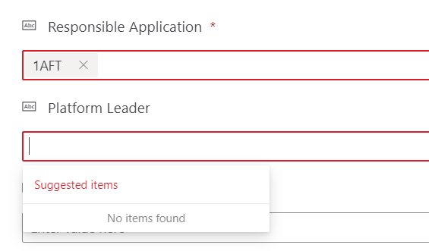

Settings of Responsible Application field
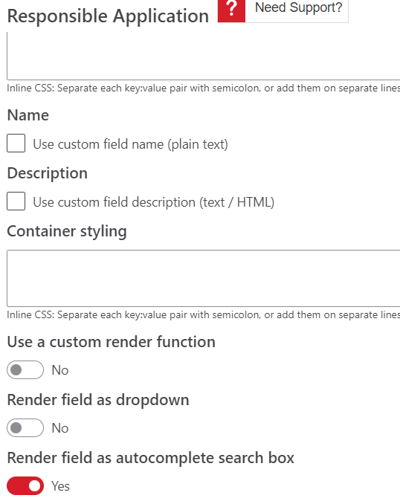

After submit it fills in the platform leader field, it should fill in once Responsible application is sleected, like it does with “Render field as dropdown”

