From DFFS EDIT/NEW form

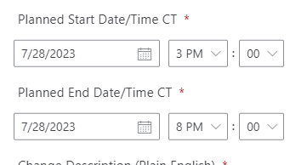

From list view

Email comes out with the dates from the list view
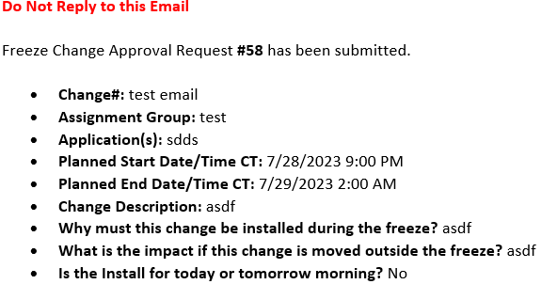

My regional settings are set to Central Time and my system settings seem to be set to be set to (UTC) Coordinated Universal Time.

SEEMS TO WORK CORRECLTLY BELOW this is why I am wondering if it might be DFFS?
I did test another list without DFFS and when I do a time conversation Power flow it works fine in both the view, form and email.

- List view for one that works correctly:
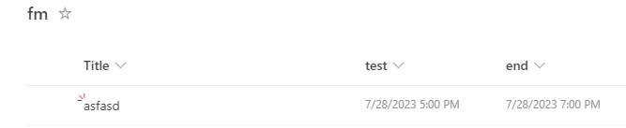

- Edit/New view
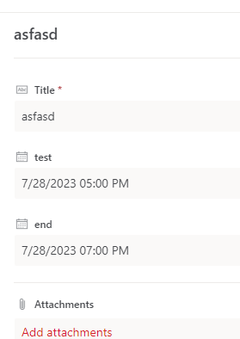

Email
