THIS IS HOW AN EIXISITNG FORM/RECORD AND NEW FORM/RECORD LOOKS:
LIST VIEW ITEM

EDIT NEW FORM

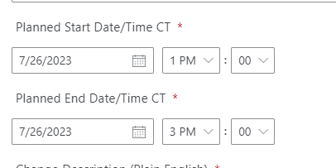

THIS IS MY WORKAROUND

Set Power Automate flow Convert Time Zone Step:

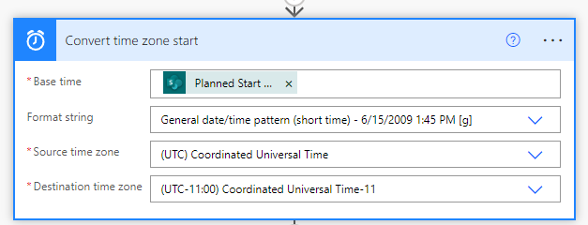

Email looks like this but list view and edit view and form look the same as above
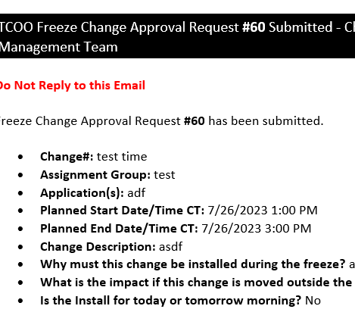

I then do an Update Item step in Power Automate Flow to update a text field with my converted time field and show those fields in the list view
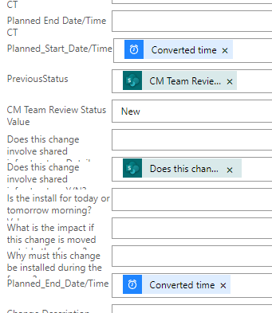

LIST VIEW WITHUPDATED TEXT FIELDS

INFORMATION FROM TOOLS CONSOLE
"serverTime": "2023-07-28T16:45:53.2645245Z",

"preferUserTimeZone": false,
"userTimeZoneData": null,
"CalendarType": 1,
"userTime24": false,
"userFirstDayOfWeek": null,
"webTimeZoneData": {
"Description": "(UTC-06:00) Central Time (US and Canada)",
"Bias": 360,
"Id": 11,
"DaylightBias": -60,
"DaylightDate": {
"Year": 0,
"Month": 3,
"DayOfWeek": 0,
"Day": 2,
"Hour": 2,
"Minute": 0,
"Second": 0,
"Milliseconds": 0
},
"StandardBias": 0,
"StandardDate": {
"Year": 0,
"Month": 11,
"DayOfWeek": 0,
"Day": 1,
"Hour": 2,
"Minute": 0,
"Second": 0,
"Milliseconds": 0
},
"WorkHours": {
"WorkDayStartHour": 480,
"WorkDayEndHour": 1020,
"WorkDays": 62
}
},
"webTime24": false,
"webFirstDayOfWeek": 0,
"DayOfWeek": 0,
"Day": 2,
"Hour": 2,
"Minute": 0,
"Second": 0,
"Milliseconds": 0

