Hello Alexander,

I am using Modern (online) SharePoint

Here is a screenshot of Modern DFFS v 1.0.13.0 date

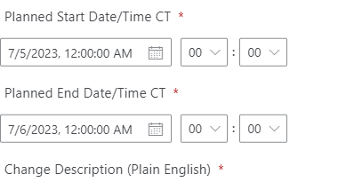

On prem classic

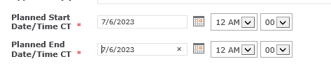

And here is the attachment issue:

Rule

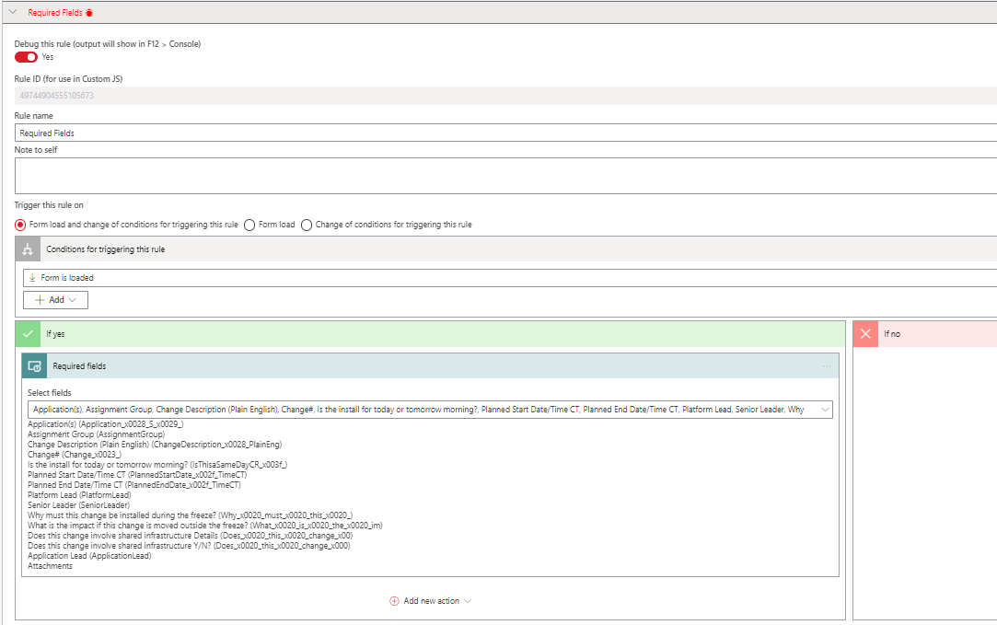

- When requiring fields, I notice that it does not recognize the Attachments field.

Here is what it looks like when I don’t add an attachment which works
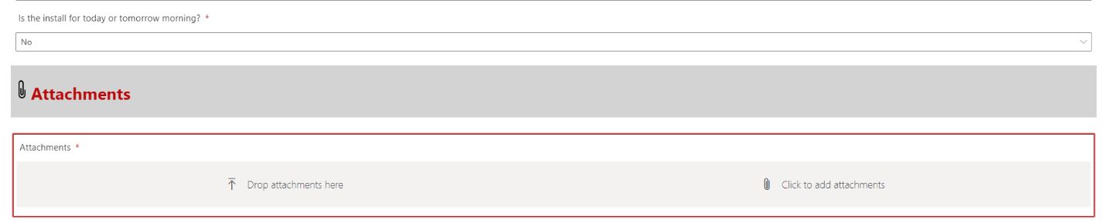

But when I add an attachment I still cannot upload as it flags it as required still
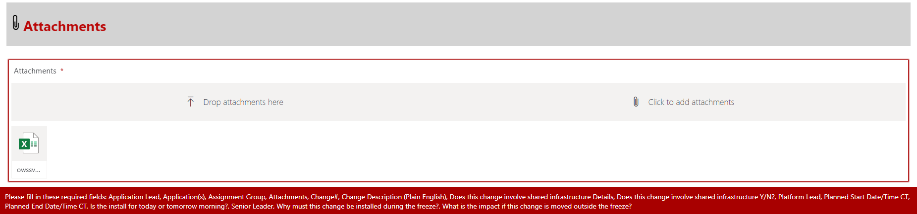

Thank you!

