Rules for Edit Form
Picture1: Rules for Tab1
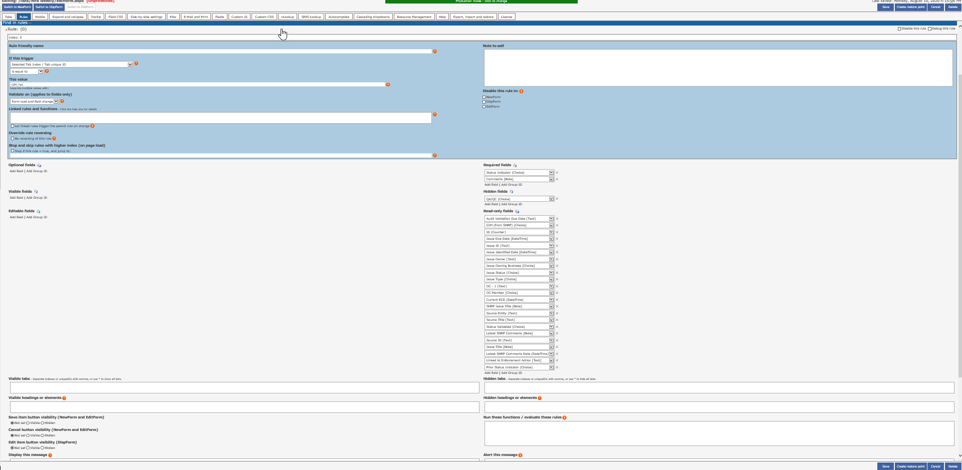

Picture2: Rules for Tab2

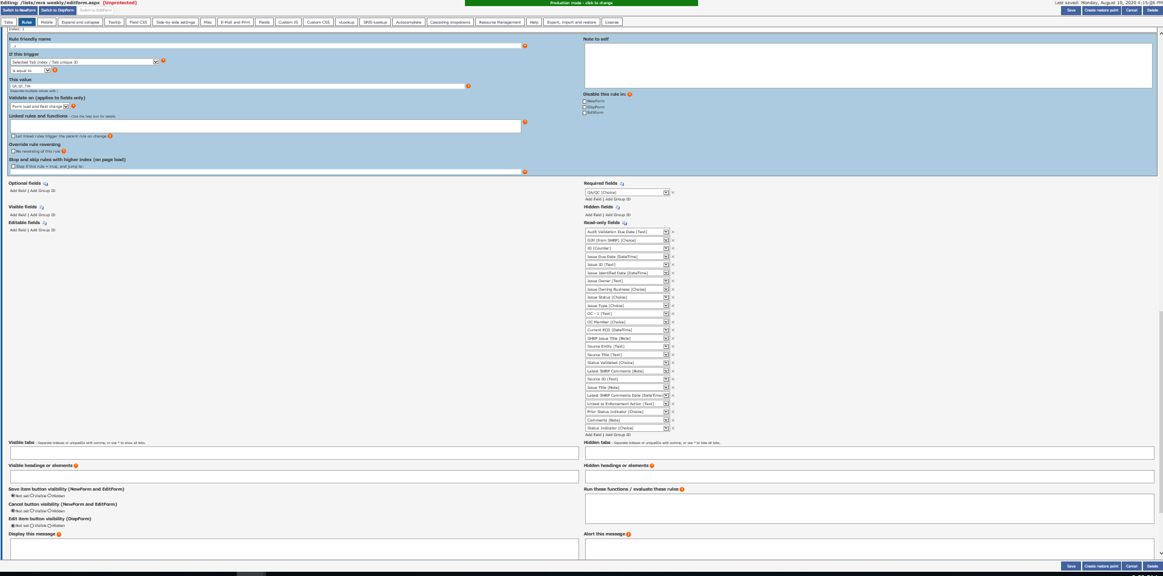

Picture2: Rules for Tab3

