I have three tabs in Edit Form… This is the tab which does not display the Read Only attributes in correct manner when loaded the first time (Picture 2). When you click the tab the second time, everything displays as intended (Picture 3)
Picture1: Configuration setup for the Tab in DFFS
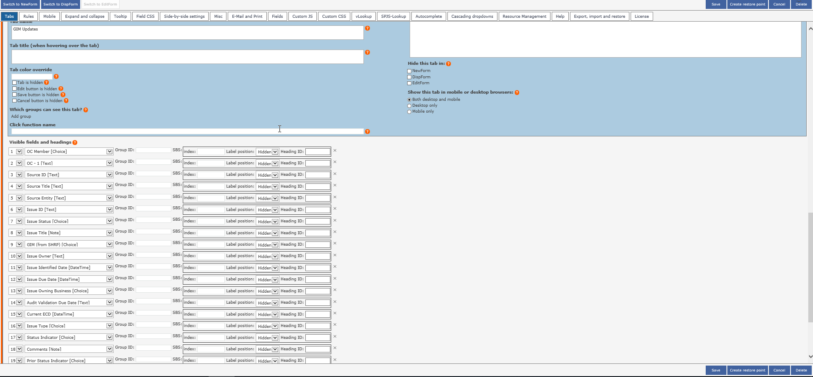

Picture2: SharePoint display on first time load of the page: Many Read only fields are displayed as editable and users can edit them
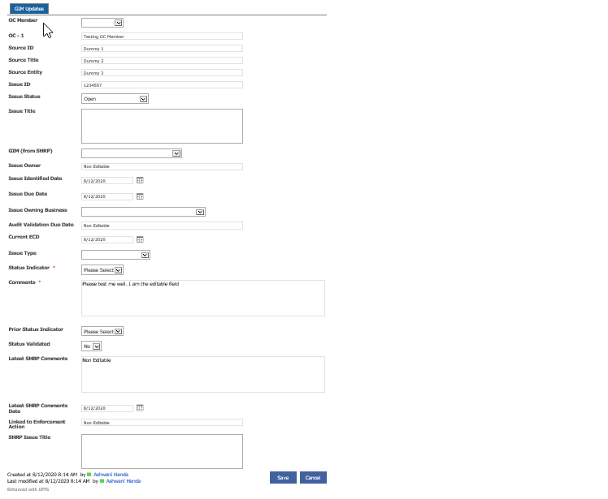

Picture3: SharePoint display when you click the tab the second time: Clicked on tab “GIM Updates” again and now the fields are rendered well. Only two attributes are displayed as Read Only

