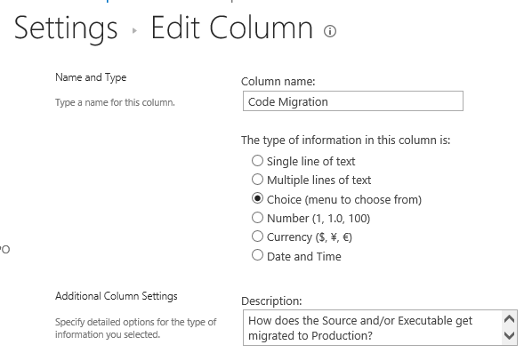

This is how it looks on the form:
This is how I want it to look, made the changes in f12:
But I don’t want the bottom of the form to change to bold and 12 pt….
