Parent Form with Child vlookup form:
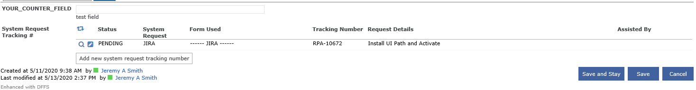
Click the Add new system request tracking number button
Child form (as seen in a dialog window above parent)
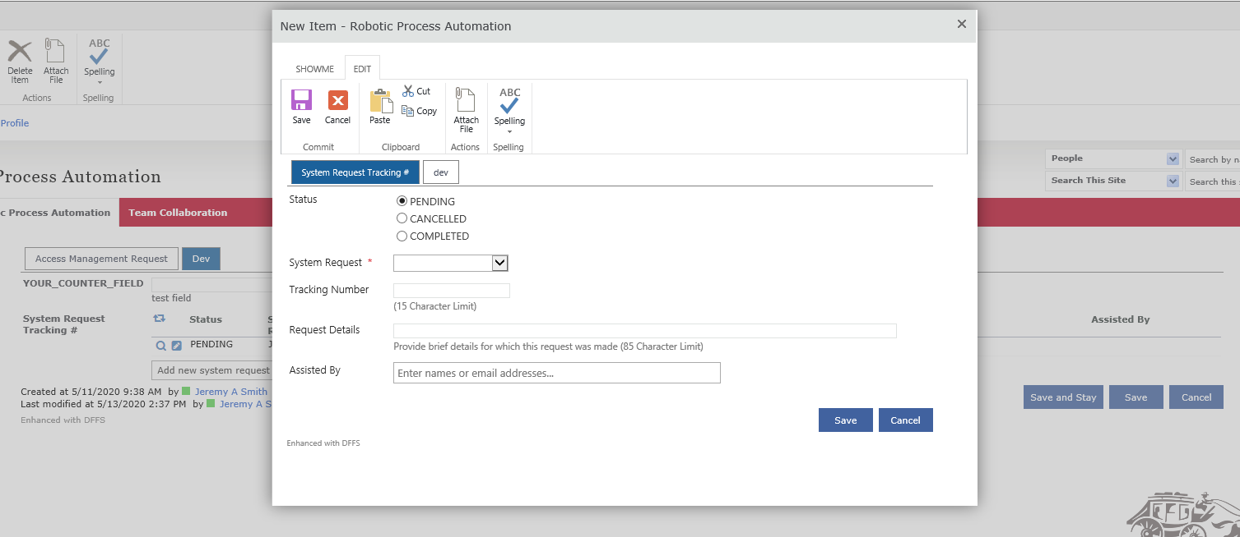
Enter all the information into the fields
Click save to save the details of the item
After hitting save and the window closing, I would like the following to happen
- The child form displays the entry like seen in the first screenshot on the parent page, while
- The value listed as RPA-10672 (pulling from the Child field (internalname: Title) Tracking Number is carried over to the parent form field (internalname: YOUR_COUNTER_FIELD) YOUR_COUNTER_FIELD

