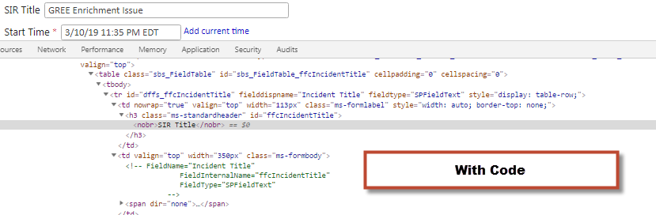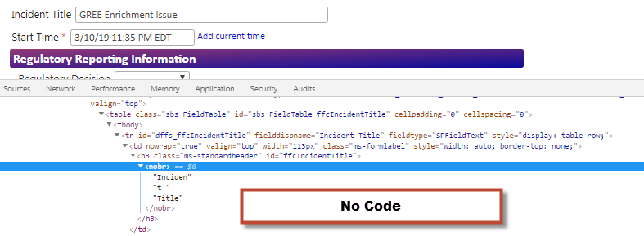

Functionality when click through tabs. The Full Form Tab Should read Incident Description (used for email subject line)
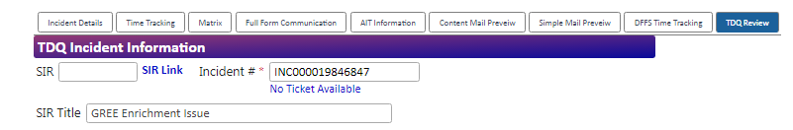
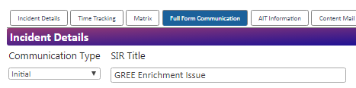
Click on any other tab, then back to the full form tab…
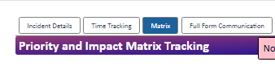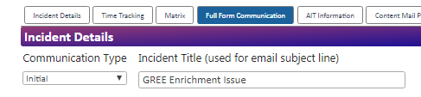
If I click the label then go to the TDQ Tab where the title should be SIR Title, the label is wrong
