EditForm.aspx debug:
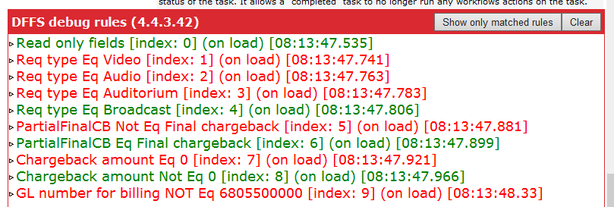

I get these errors when I try to open the edit form. When I apply the latest version (2018-04-15) of DFFS it does appear to be loading correctly, but I’m not sure why I am getting these errors when I did not get them before.
