I have quite a few tabs on a form in a site. Would like to set up the tabs on multiple rows. I used the setting on the Misc tab in DFFS as shown in the following screen shot.
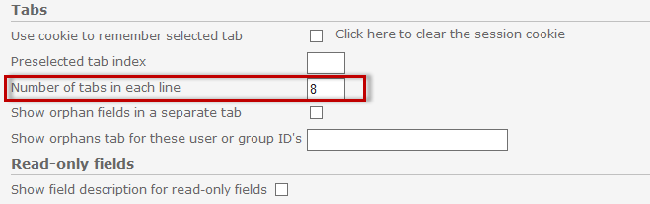
However, when I save the form, it puts tabs 9 & 10 above instead of below the first 8 tabs.
Is there a setting that will make the tab rows fixed so that the first 8 show on the top row and the remaining tabs show on the 2nd row?

