Workstream Impact Field and the Multiple Choice Drop-Down Selections:
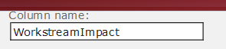
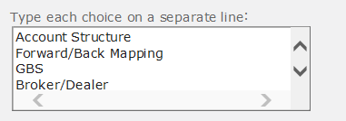

Rules shown below – scroll down….

Rule 0:
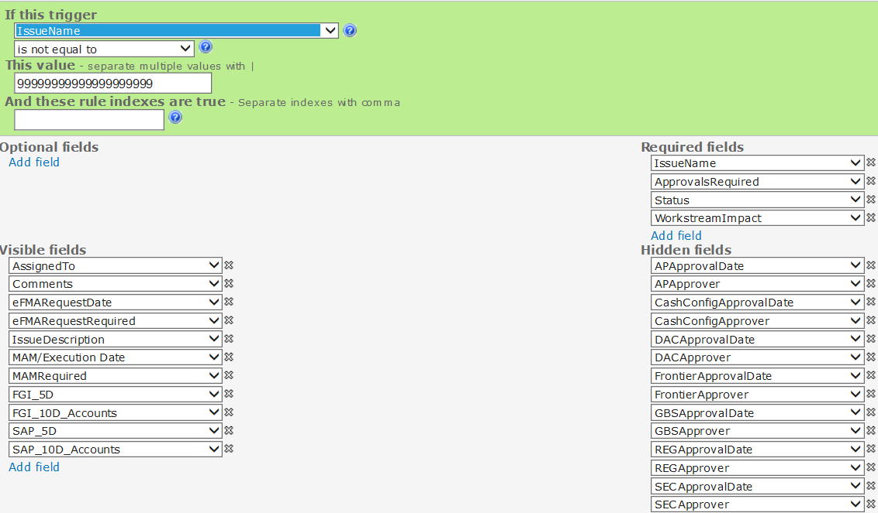
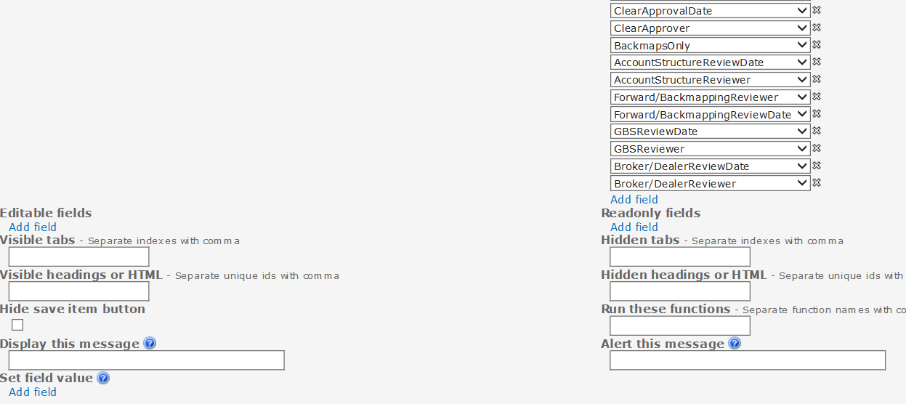

Rule 0 is there to setup the form and apply hidden/display/required items for all Items that are created.
Rules 1 – 8 are related to a different Multiple Choice field, so I am skipping those and showing you rules 9-15 that apply to the WorkstreamImapct field. Logic will be identical as it relates to Rules 1-8, its just there are 8 options there instead of 4. If I can get it to work for 4, I can apply it for 8.

Rule 9:
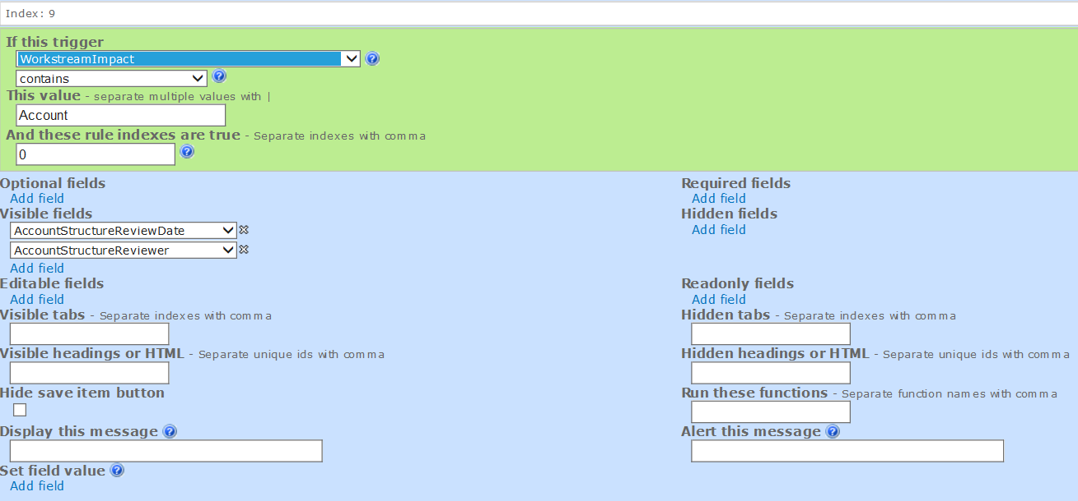
Rules 10-12 are the same as 9, except with a different value
Rule 10:
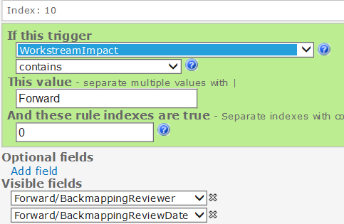
Rule 11:
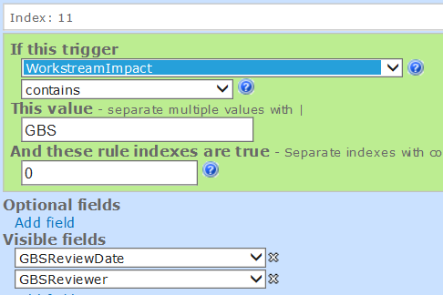
Rule 12:
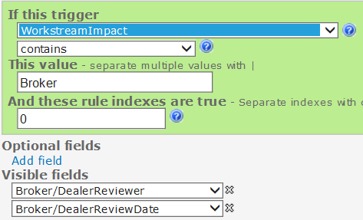

Rules 13-16 are Identical except for the “And these rule indexes are true” field as that changes to match Rules 9-12 and therefore the “Required” fields change to match the field reflected in Rules 9-12
Rule 13:
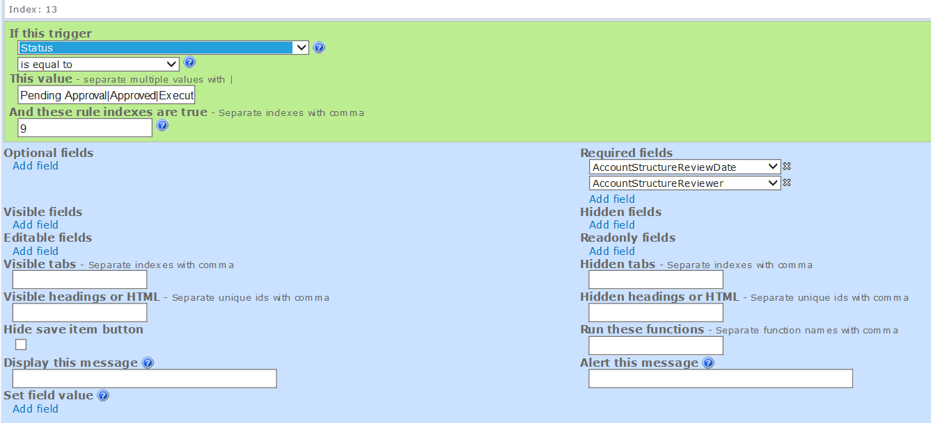
Rule 14:
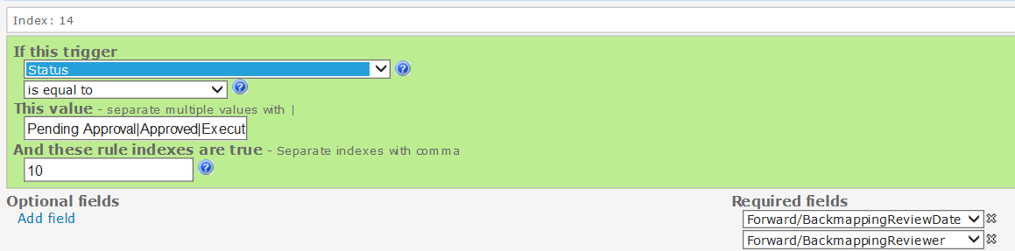
Rule 15:
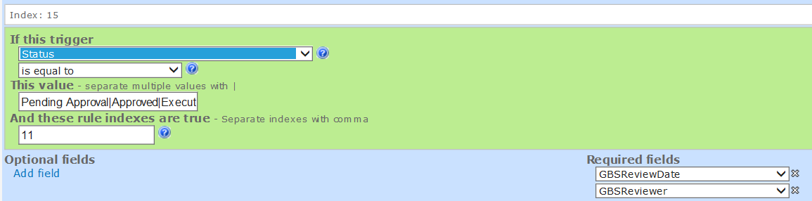
Rule 16:
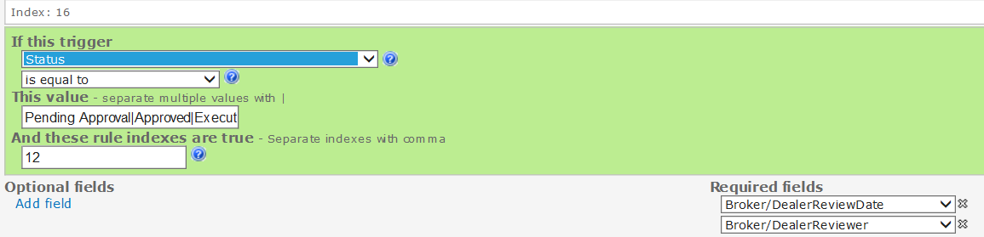
When I apply this to the form, it works as expected for 1 item checked. But not multiple
Just Account Structure Selected:
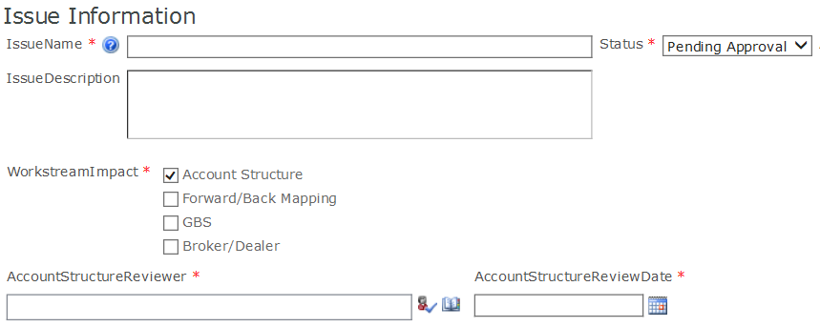

With Account Structure and GBS: (Account Structure being required does not work)
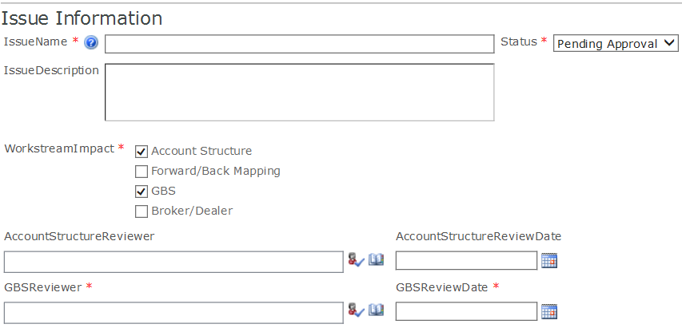

One more example below….

Last example – GBS and Broker/Dealer – now only Broker/Dealer will show as required
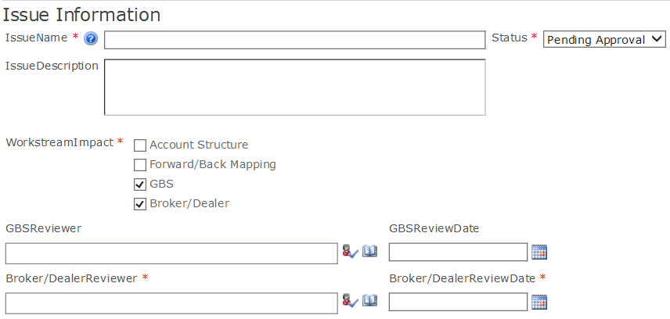

It appears to me that the “Required” rules (13-16) only apply to the lowest selected item in the Multiple Choice drop-down (very first screenshot on page 1)

