Using DFFS v.4.4.2.2 in SP2010
When Cascading Dropdowns plugin (version in DFFS 4.4.2.2 package), EditForm is broken with a pre-existing Casc configuration (3 columns/levels utilized). DFFS setup link is still visible and functioning. I cannot remove the Casc configuration in the backend UI. I posted separately about this.
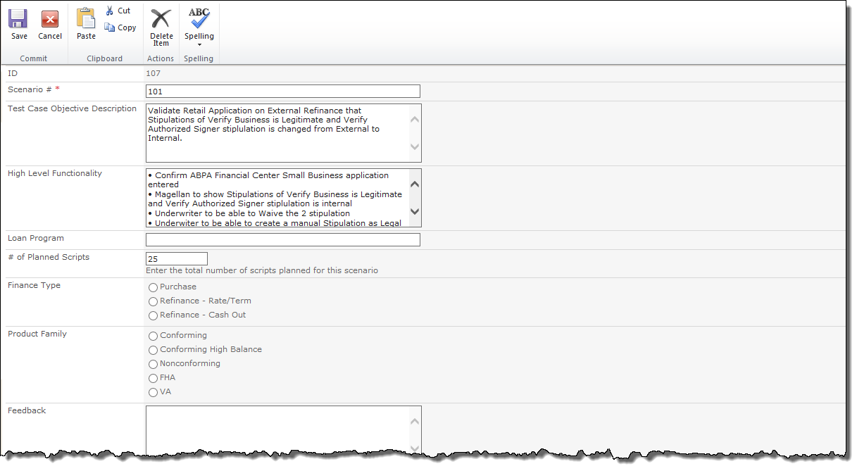
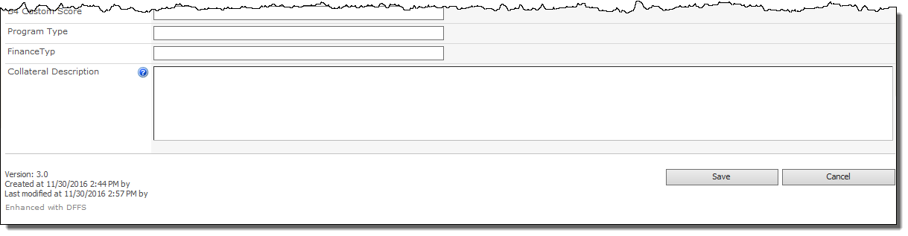
Here is what I see when debugging in the Dev console.
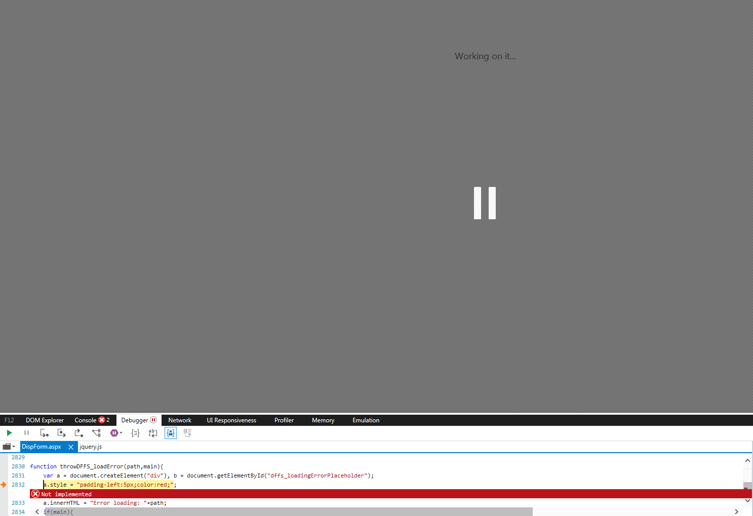
Here is the Casc setup that was working before.
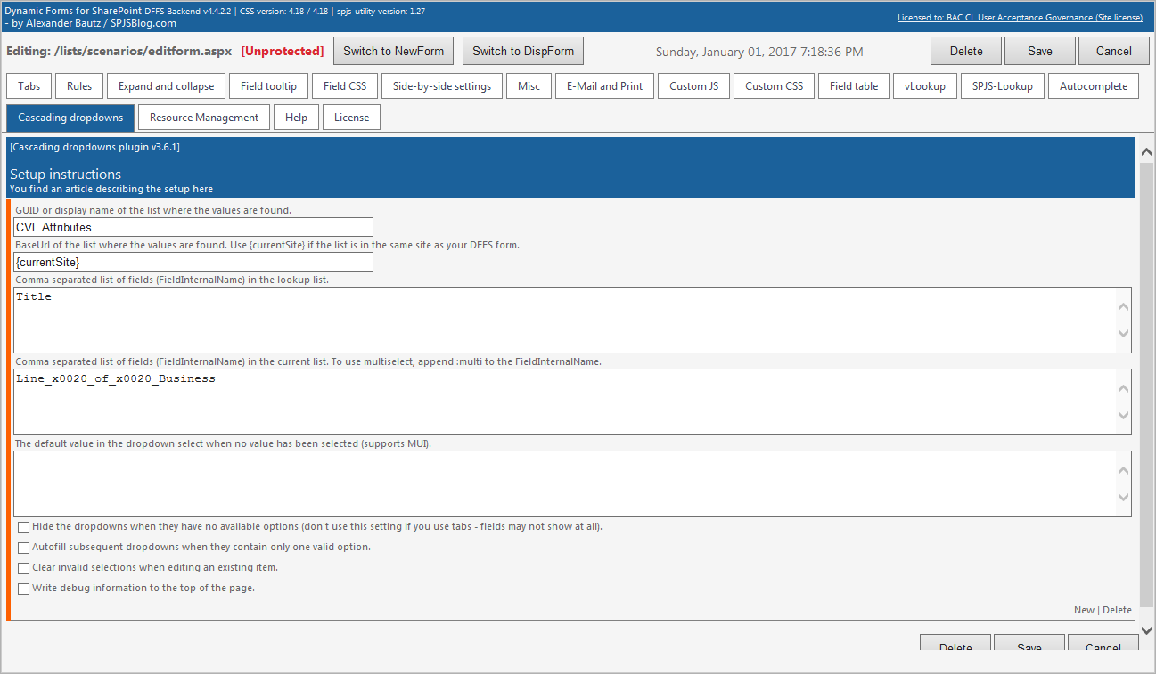
When I overwrite the current Casc plugin JS file with the version that came in the DFFS v4.4.2.0 package, the form loads correct (see below). BUT…
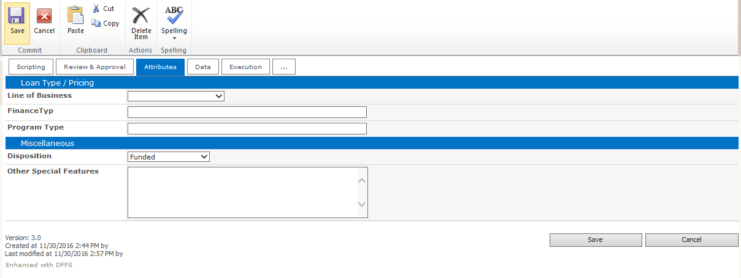
When I go into the backend config, the UI doesn’t load the content below/within the tabs
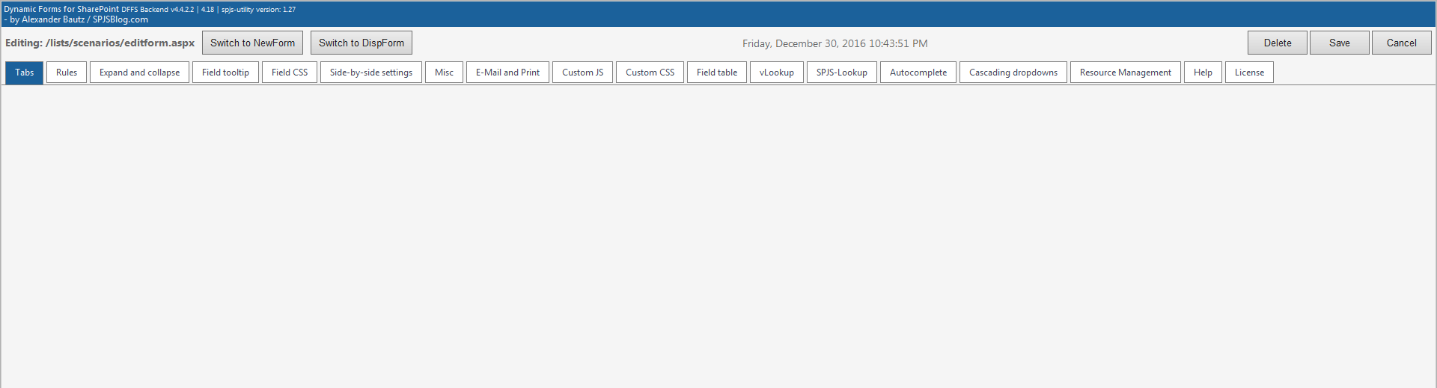

I also tried removing the Cascading Dropdowns setup that I created in the backend but it won’t let me. This is what I posted separately about here: http://spjsblog.com/forums/topic/remove-cascading-dropdown-config-in-dffs-backend/
