Now that the Side By Side labels are lined up with the fields that are configured as side by side, I’ve encountered a new issue.

The form shows blank lines for every row that contains hidden fields.

For example:

When the New form first loads, I have a rule that hides every field, field label and heading except the heading “Select an Option” and the field Request Type and its field label.
As you can see from the screen shot, there are quite a few “blank” lines that still show on the form below the row that the Request Type field is on. The number of lines that show seem to correspond to the number of Side by Side field labels and fields that are hidden.

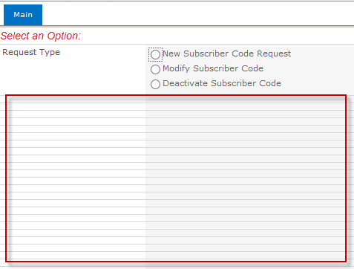

Here are screen shots from the first rule that runs when the form is loaded.

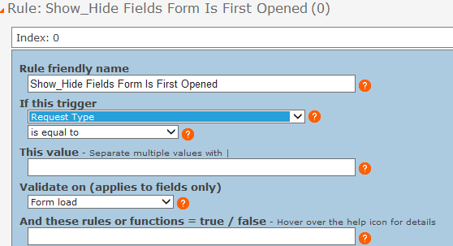
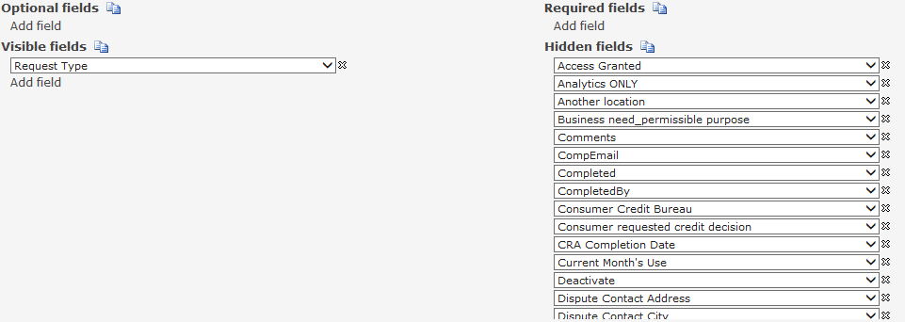

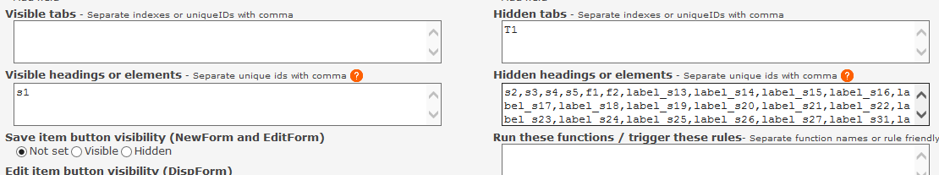

The Visible fields section contains the only field that should show and the Visible heading section shows the Heading that should show on the form when it is loaded.

The Hidden headings or elements section has the list of Headings on the tab and the SBS-LabelID values from all of the Side by Side field labels that are supposed to be hidden.

Here is a screen shot of just a part of the Side-by-side settings. All of the SBS-LabelID values that are supposed to be hidden are listed in the Hidden headings or elements section of the rule shown in the above screen shot.

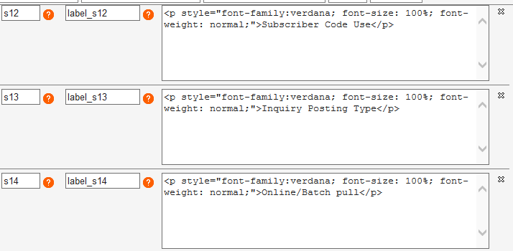

Now when a value in the Request Type field is selected, other rules are carried out and depending on the selection a different set of fields show on the form and the number of blank lines decreases by the number of fields that show.

