Field CSS setting.

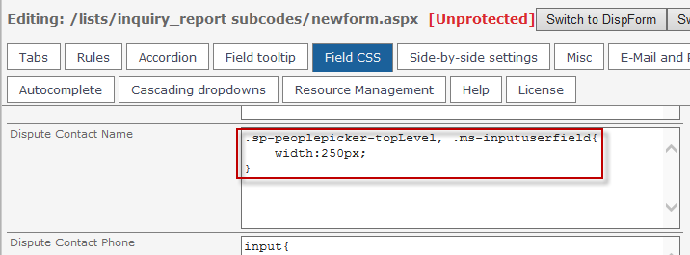

What the field looks like when the form is opened.

