Issues with using Side By Side.

I added the following side by side configuration to the tab that displays the following fields. Please note the numbers associated in the screen shot.

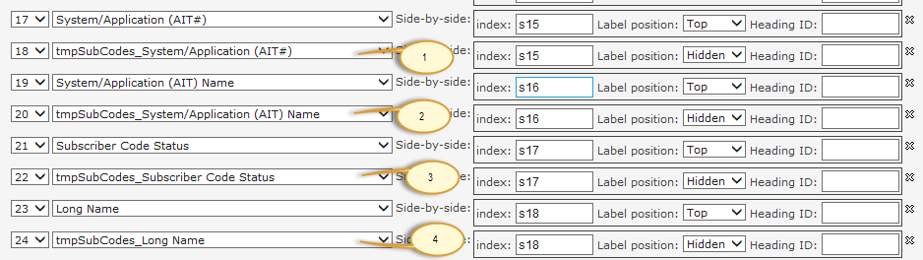

And I configured the Side-by-side settings.

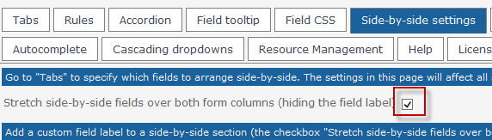

When I open the New form to create a record, the screen looks like this.

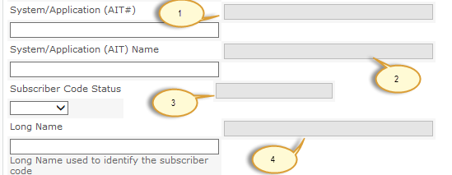

The fields are not evenly spaced across the page. Each of the fields that appear to be grayed out, numbered 1 – 4, should be on the line below where they currently show.

I set the Label Position for the fields in the right column to be hidden and the labels for the fields in the left column to be on top.

So my questions are:

- How can I space the fields so that the ones that are supposed to be on the same line show on the same line regardless of whether or not they have a Label?
The field in the right-most column, shows as grayed out in the above screen shot, are 1 row above where they need to be. Field #1 needs to be on the same row or line as the field under the label – System/Application (AT#) and so on.
- How can I set the columns so that they are the same width across the page.

And another issue cropped up. As you can see from the following screen shot, the Person or Group field is barely wide enough to allow a user to enter a single character. The field does expand as a user enters a name, but that is not the behavior that I would expect.

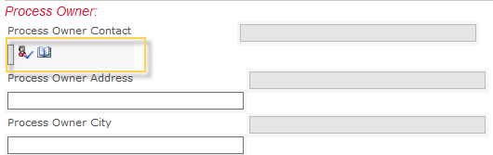

Is there a setting that will allow this field to fully expand within the first column?

