Issue with tabs not working with an external list.

I created a table on a SQL server that has 4 columns.

- id
- name
- narration
- multiline
I also created the External Content Type that allows the SharePoint site to access the table. I added DFFS to the display form and created 2 tabs and selected the columns that I wanted to display on each tab.

The following screen shot shows what the form looks like when you click the first tab labeled Main.

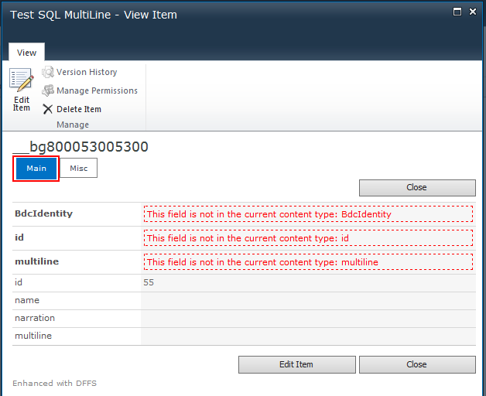

The next screen shot shows what the form looks like when you click the 2nd tab labeled Misc.

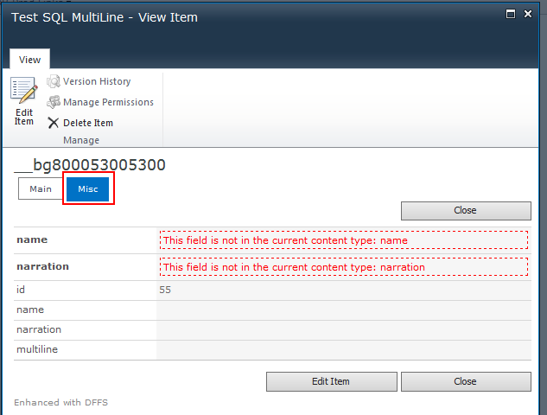

Both tabs contain the same fields regardless of how you configure the tabs.

Here is a screen shot of the first tab labeled Main in DFFS. I’ve highlighted in red the fields selected for the tab.

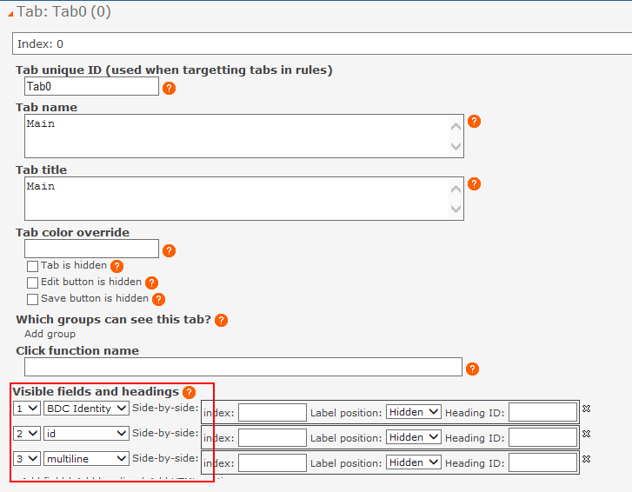

And here is a screen shot of the 2nd tab labeled Misc. Again the fields selected to show on this tab are highlighted in red.

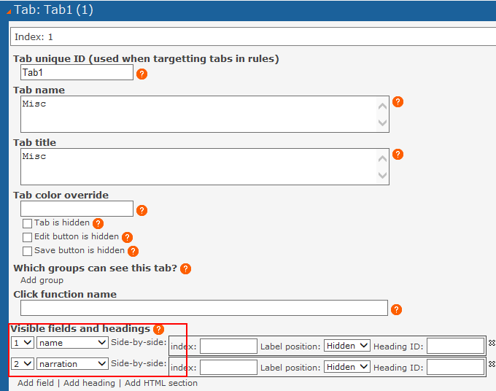

As you can see, the Main tab has 3 fields listed and the Misc tab has 2.

You can see the obvious differences when the form is actually displayed to the user. It shows the selected fields per tab with that error message about the field not being in the content type as well as each tab shows all of the fields and their contents on both tabs.

And as you can see, DFFS recognizes the fields from the external list.

