Prior Version  Autocomplete: not loaded  Cascading dropdowns: 3.524  DFFS frontend: 4.306  jQuery: 1.11.2  Lookup: not loaded  Resource management: not loaded  SPJS-Utility: 1.21  vLookup: 2.209 | New Version
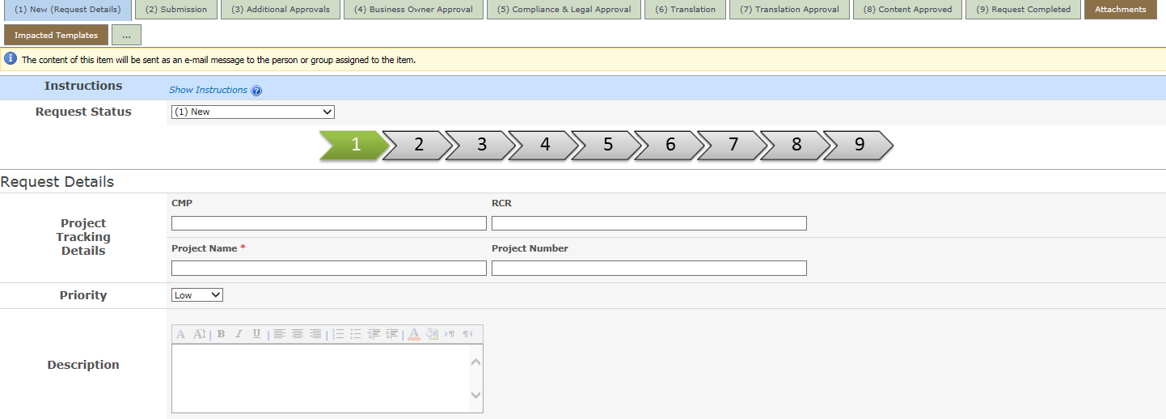 | 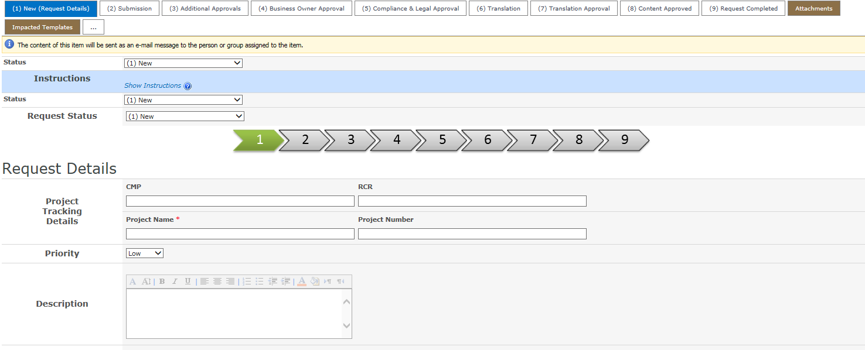
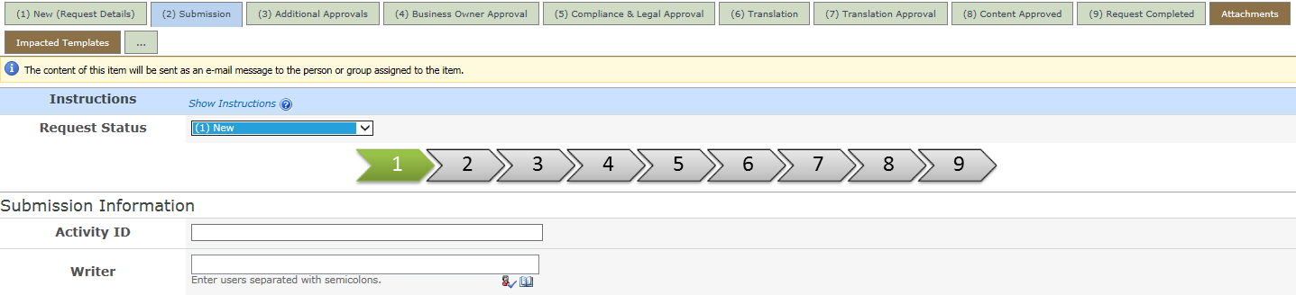 | 