- View of page at initial launch of NewForm.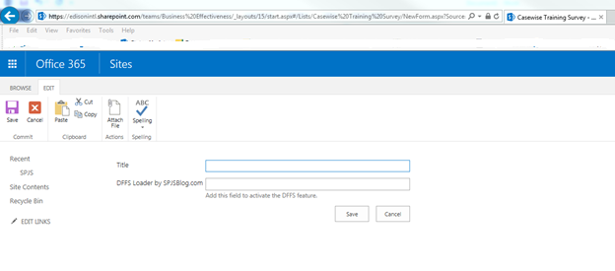
- There is no name listed for the dynamics in the Editing section.
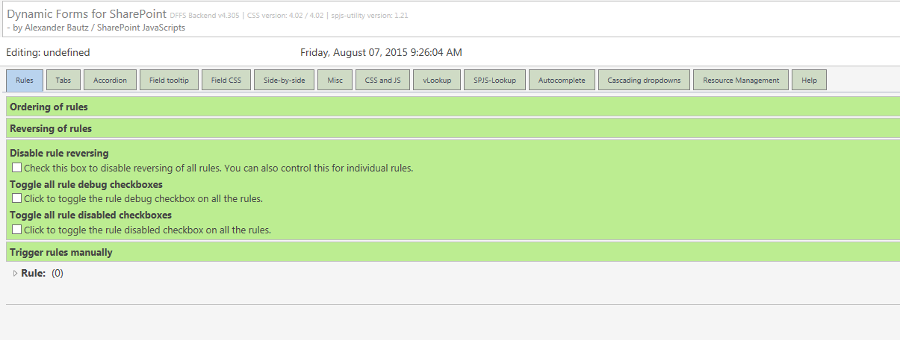

- SPJS-DynamicFormsForSharePoint list view of “undefined” record.
