Here is my current set-up:
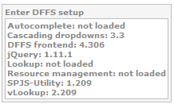
Here is what my Back End configuration looks like for hiding the Form Label:
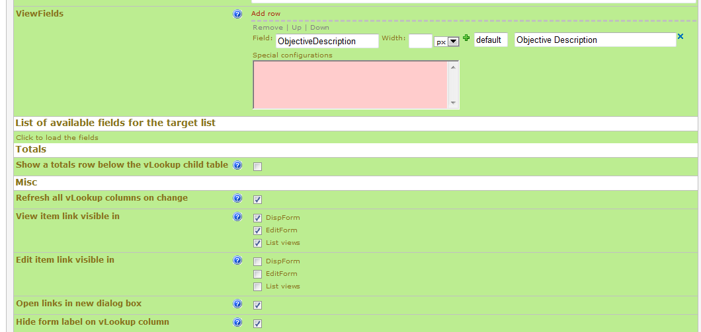
Here is the result in my List View:
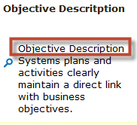
Objective Description is the Form Label…..if it is supposed to be hidden, why is it appearing in my list view?

Thanks!
Lana

