I am having issues with the current vLookup.
I am using:
DFFS Frontend 4.255
DFFS Backend 4.254
Spjs-utility 1.206
vLookup Frontend 2.104
vLookup Backend 2.003

I have created a Parent Child Setup.
I can get the Child list to populate, but not have it display on the Parent List.
Below is a Screenshot of the Parent List View:
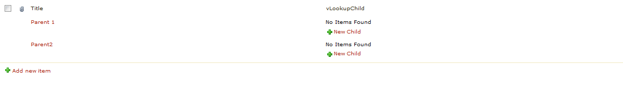
Here is the Child List View:
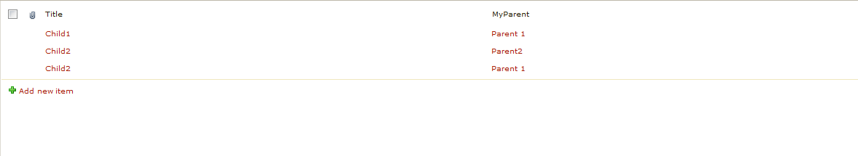
Below are my DFFS Configuration Settings for vLookup. I figure I had to have done something odd here for it to not be working, but for the life of me I can’t figure out what.

