- Changed how read only fields are “styled” when using side-by-side to try to maintain the width of the field. This change needs testing – let me know how it works in your setup. [thespiandave: I never used this setting before, but I changed it on my form and below is the result.]

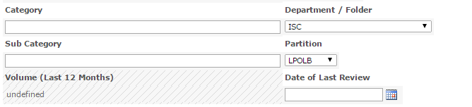
- Changed how initial value is retrieved when the form loads. Previously DFFS read the values from the fields using the function “getFieldValue”, but now it uses a web service call to get the current item metadata from the DB. This is done to try to overcome the problems some have been experiencing with people pickers not being ready when set to readonly when the form loads. This change needs testing – let me know how it works in your setup. [thespiandave: I never used this setting before, but I changed it on my form and below is the result (English Approval - Writer is a "People Picker" and this is the EditForm.aspx page.]
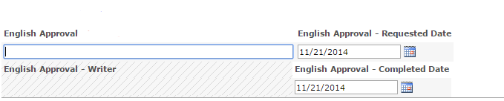
- Changed how you reorder fields in tabs in the backend. [thespiandave: Worked Great! Thanks!]
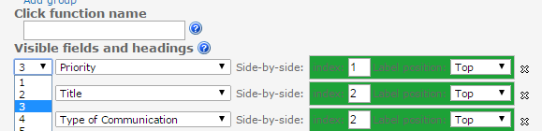
- Boolean values will be displayed as checkboxes in DispForm. [thespiandave: I never used this setting before, but I changed it on my form and below is the result. The "Boolean Test" field showed 'Yes'.]

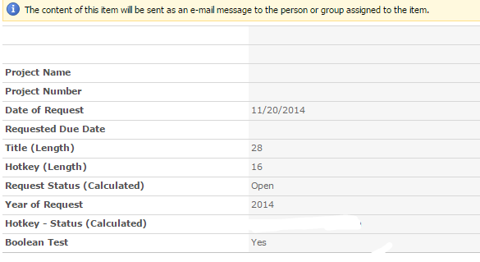
- New: Changed tab color on hover to a slightly lighter color (update CSS file for the frontend). [thespiandave: Worked Great! Thanks!]
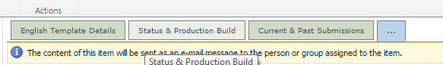
- Added class “dffs-accordion-activePanel” to active accordion panel. You can use this class for your “custom code”. [thespiandave: I don't use the accordion feature and wasn't able to test this.]
- New: Added support for comparing dates with hours and minutes. Please note that you cannot use hour and minute when comparing dates in DispForm. [thespiandave: I haven't used this type of rule before. Do you have an example of how it should be written?]
- New: Added “between” operator. [thespiandave: I tried using this, but it didn't seem to work for me. At least using the "Display this message" or "Alert" option" in DispForm.aspx]
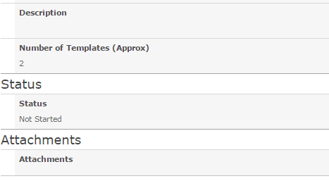
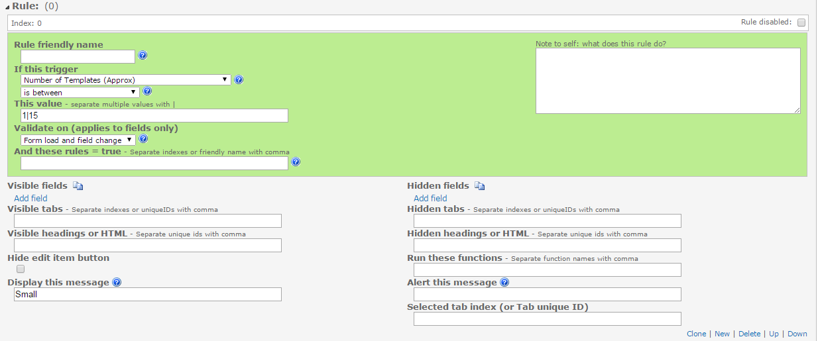
- New: You can now add a new field to the list from the Misc tab (SP 2010 and 2013 only). [thespiandave: Tested - worked great! This is a NEAT feature!!!]

Bugfixes
- When no configuration has been created for a form, the overlay would time out with “This took forever”. [thespiandave: Tested - worked great!]
- When using side-by-side and hidden label you could got a linefeed after the star that indicates that the field is required. [thespiandave: I never used this setting before, but I changed it on my form and below is the result.]
- Selected tab index trigger: added “change event” as this trigger only fired on load and not on change of tab. [thespiandave: This worked fine - I was able to run a rule with the "Form Load" only and it didn't run the rule when I changed the field. The only "catch" I noticed is that my "Message" didn't display. The rule should set the field to "Read Only" - and - display a message. That didn't happen - but ONLY when I had the "Read Only" option set. This was on EditForm.aspx]
  - No "Read Only" option
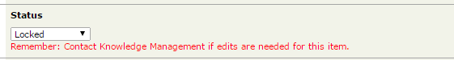
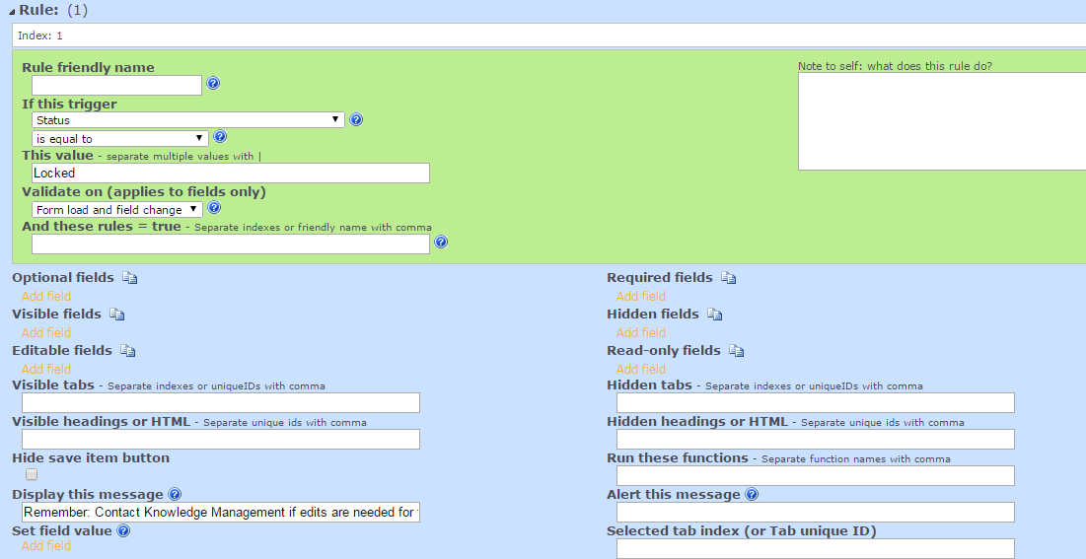
- "Read Only" option
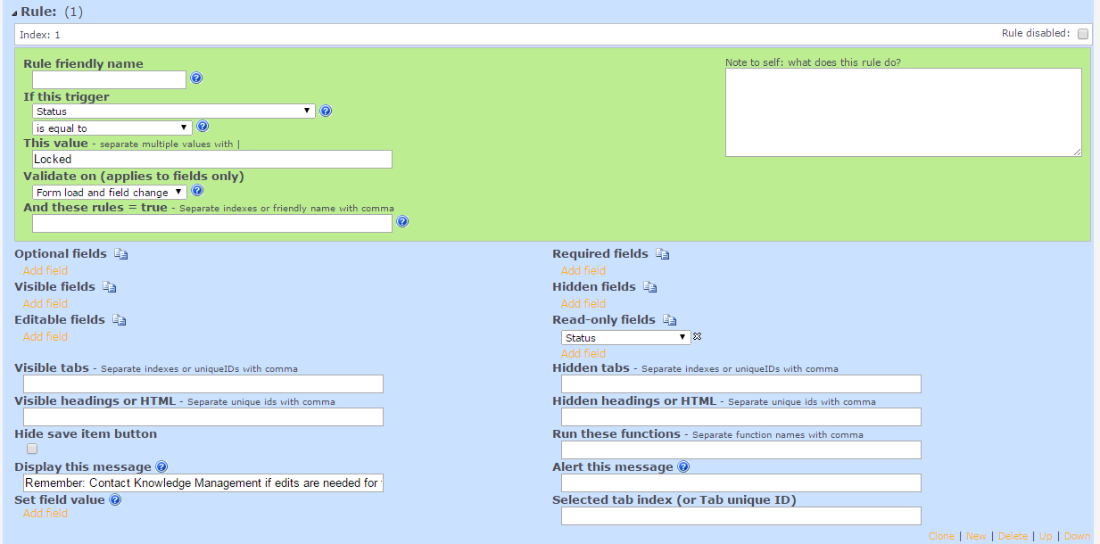
- Only the first rule using the trigger “Selected tab index” could be used in “and these rules are true”. [thespiandave: Was not able to test.]
- The rule debug output was missing “run these functions”. [thespiandave: Was not able to test.]
- Date pickers: In some cases, errors would appear in the developer console in SP2013 when operating date pickers. [thespiandave: Was not able to test.]
- Date pickers: The “blur” event was not triggered on the “master” datepicker when using “linked” datepickers and modifying the “slave”. [thespiandave: Was not able to test.]
- When a field was configured in DFFS, but it was not in the current content type, you could in some cases get an error like “unable to get the property “hidden” of undefined or null reference” in the developer console. [thespiandave: Was not able to test.]
- The Attachement field will no longer trigger the “orphans” tab. [thespiandave: Tested - worked great!]
- In the frontend I have changed from referring jQuery as $ to use spjs.$ due to an error in SharePoint when using rich text fields and “Insert > Link > From SharePoint” as the file “assetpicker.js” will “kill” jQuery by overriding the global $ variable. This would result in a complete halt in all the functionality in DFFS (and other plugins using jQuery). Please note that other plugins must also be updated. Look at the change log for each one to see which one have been updated. [thespiandave: Was not able to test.]
- Scroll to first input will no longer make the form scroll down. If the first input is off the visisble sceen, it will not get focus. [thespiandave: Was not able to test.]

