The vLookup column is working just fine on DispForm.aspx using the DFFS_frontend_CEWP.js.aspx file.
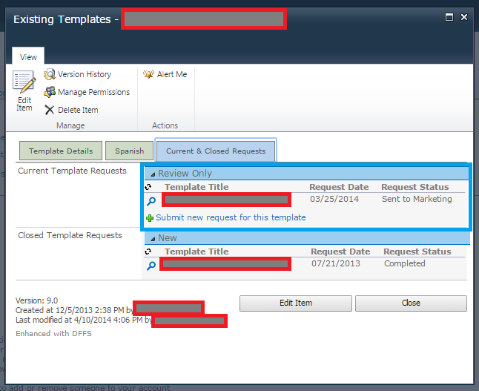

When looking at this column in ListView, the information is not shown. (See blue boxes).
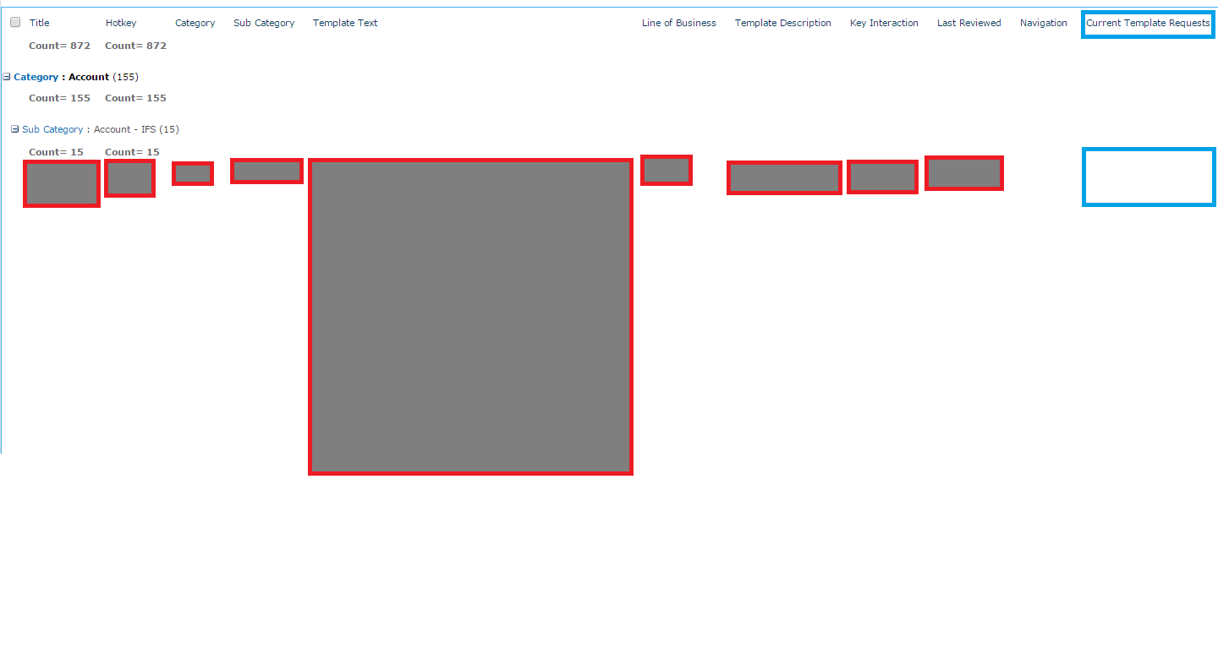
I've ensured that the "Add new item" option for "List Views" is checked, and it is. 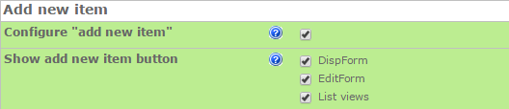

I've tried using both the HTML Form Web Part.
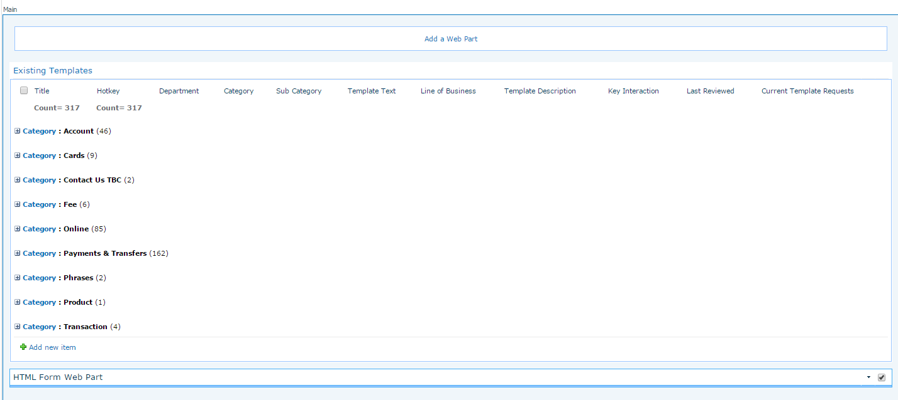

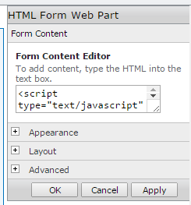
<script type="text/javascript" src=" /sites/splqtmmy/Email/SiteAssets/DFFS/jquery.min.js"></script>
<script type="text/javascript" src=" /sites/splqtmmy/Email/SiteAssets/DFFS/spjs-utility.js"></script>
<script type="text/javascript" src=" /sites/splqtmmy/Email/SiteAssets/DFFS/vLookup_frontend_min.js"></script>

And the Content Editor Web Part linked to a Text file of the references you provided.
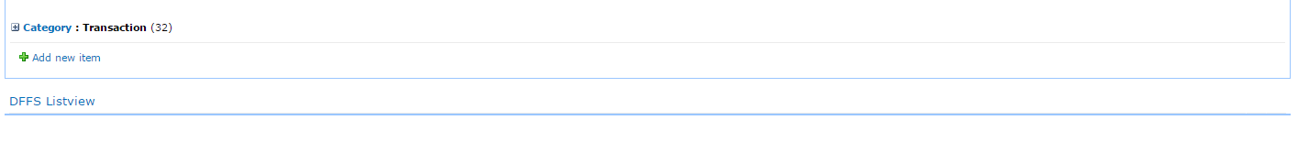
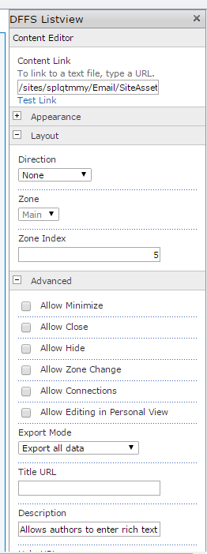
<script type="text/javascript" src="/sites/splqtmmy/Email/SiteAssets/DFFS/jquery.min.js"></script>
<script type="text/javascript" src="/sites/splqtmmy/Email/SiteAssets/DFFS/spjs-utility.js"></script>
<script type="text/javascript" src="/sites/splqtmmy/Email/SiteAssets/DFFS/vLookup_frontend_min.js"></script>

