Issue: Rule is not working "on load", but set to work "on load"
DFFS Backend v4.4.3.42|CSS version: 4.42 / 4.42|spjs-utility version: 1.323

I have created the following rule, which should work on load and on change.
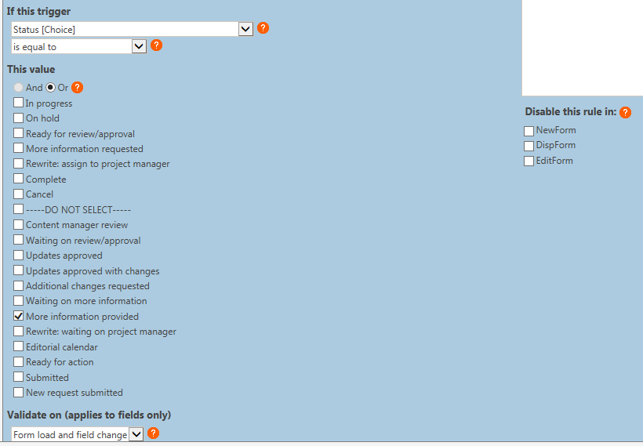
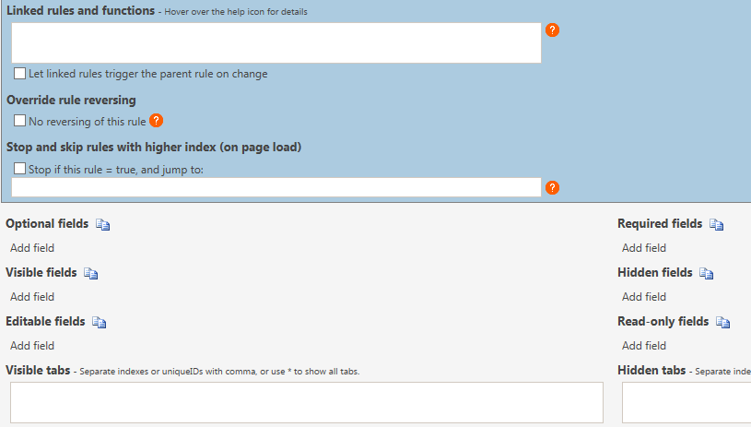
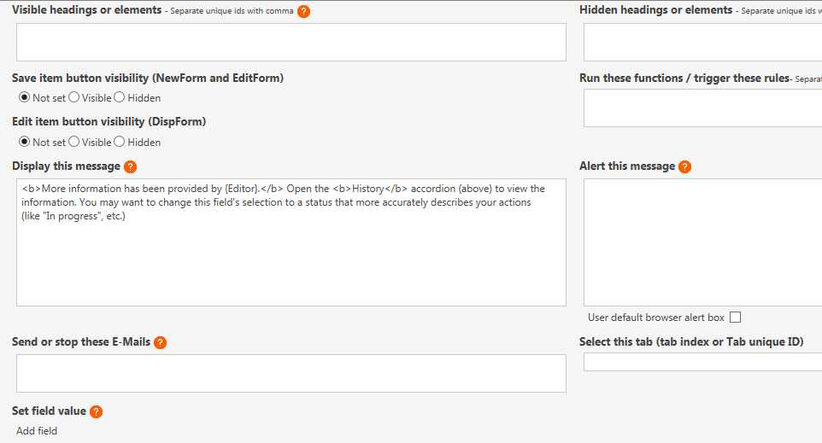

When I load the form, this field should look like this:
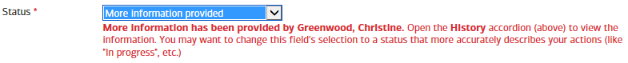

If I change the selection to something else, then change it back, I can get it to work. When the form loads, it is not adding my display message, and looks like this:
See more info on next page >>

You can see there are no errors, and the display message is set to be built. What am I doing wrong?
