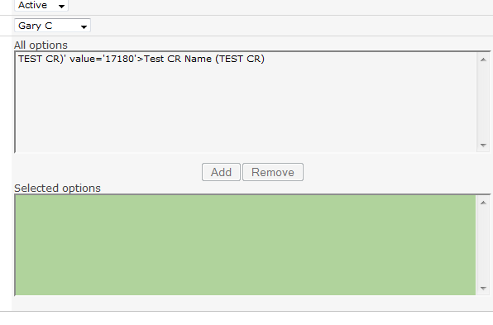

=[Project Name]&" (<a href=' /sites/SiteName/SubSite/_layouts/OSSSearchResults.aspx?k="&[CR #]&"' target='_blank'>"&[CR #]&"</a>)"

